**Session 22 Assignment 1**

val census_data = sc.textFile("/home/acadgild/KushalSession22/census.csv").map(x => x.split(",")).map(x => (x(0),x(2),x(3),x(4),x(5),x(6),x(7),x(8),x(9),x(10),x(11),x(12),x(13),x(14),x(15),x(16),x(17),x(18),x(19),x(20),x(21),x(22))).toDF("State" ,"Persons","Males" ,"Females" ,"Growth_1991_2001" ,"Rural" ,"Urban" ,"Scheduled_Caste_population" ,"Percentage_SC_to_total" ,"Number_of_households" ,"Household_size_per_household" ,"Sex_ratio_females_per_1000_males " ,"Sex_ratio_0_6_years" ,"Scheduled_Tribe_population" ,"Percentage_to_total_population_ST" ,"Persons_literate" ,"Males_Literate" ,"Females_Literate" ,"Persons_literacy_rate" ,"Males_Literatacy_Rate" ,"Females_Literacy_Rate" ,"Total_Educated").registerTempTable("census")

**1. Find out the state wise population and order by state**

val population = spark.sql("select state,sum(persons) as total_population from census group by state order by total_population desc").show

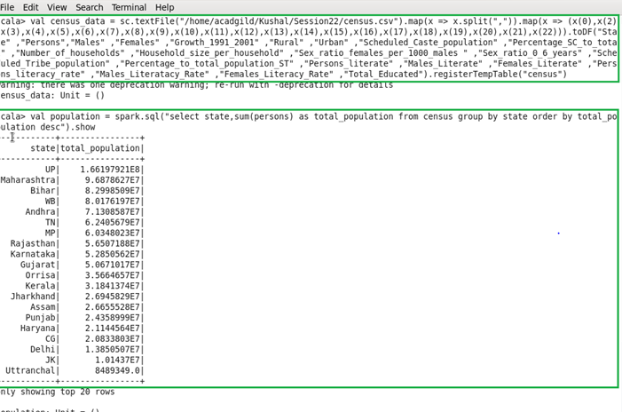

**2. Find out the Growth Rate of Each State Between 1991-2001**

val growth_rate = spark.sql("select state,avg(Growth_1991_2001) as total_growth from census group by state").show

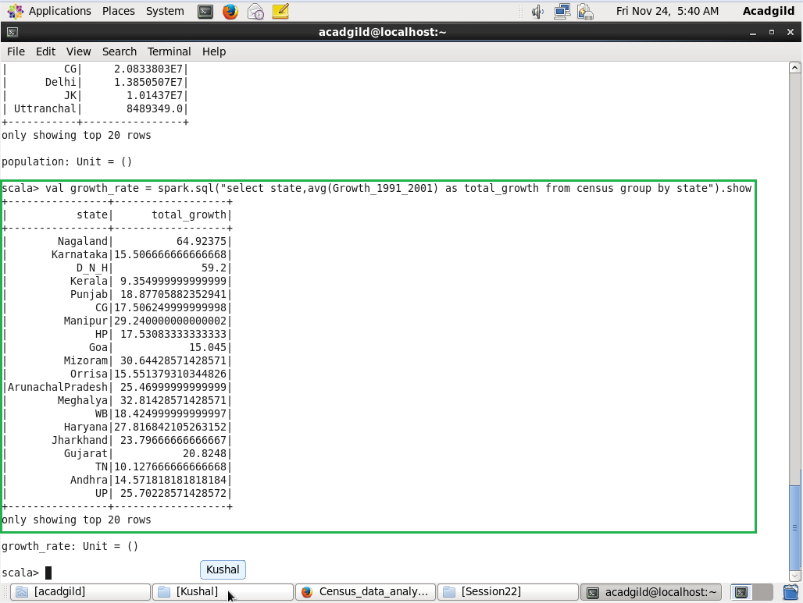

**3. Find the literacy rate of each state**

val literacy = spark.sql("select state,avg(Persons_literacy_rate) from census group by state").show

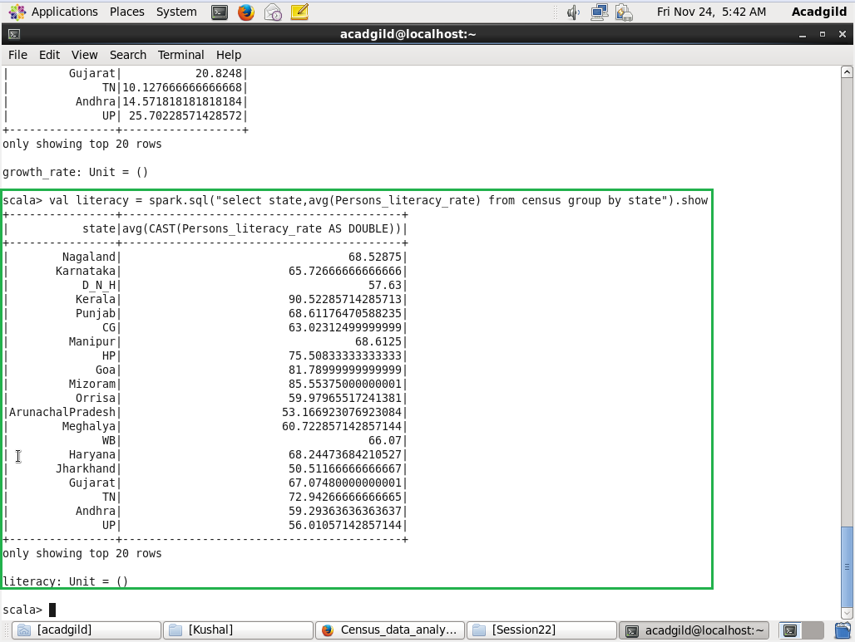

**4. Find out the States with More Female Population**

val female_pop = spark.sql("select state, sum(Males)-sum(Females) from census group by state").show

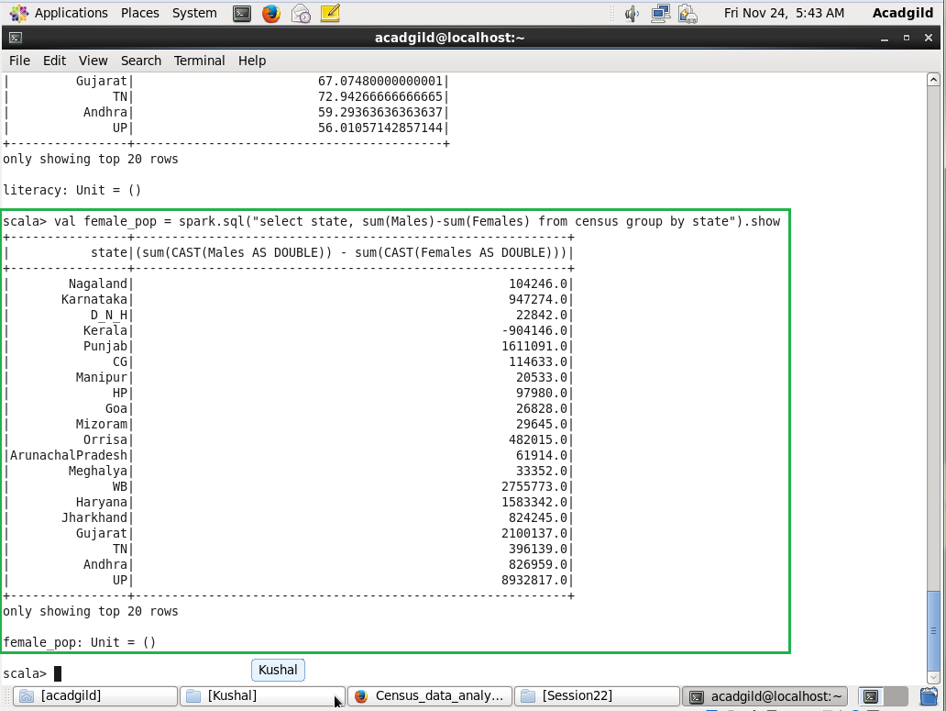

**5. Find out the Percentage of Population in Every State**

val percenet_pop = spark.sql("select state, (sum(persons) * 100.0) / SUM(sum(persons)) over() as percent_pop_by_state from census group by state").show

